**WEEK 1**

**1. What is Deep Learning?**

Ans:

Deep learning is an artificial intelligence (AI) methodthat teaches computers to process data in a way inspired by the human brain. Deep learning models can recognize complex pictures, text, sounds, and other data patterns to produce accurate insights and predictions.One can use deep learning methods to automate tasks that typically require human intelligence, such as describing images or transcribing a sound file into text.

Deep Learning can be considered subset of Machine Learning

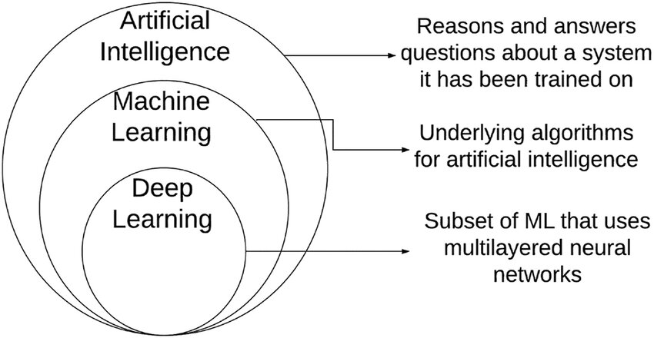

2. **What is a Neural Network and its types?**

**Ans:** A neural network is a software solution that leverages machine learning (ML) algorithms to ‘mimic’ the operations of a human brain. Neural networks process data more efficiently and feature improved pattern recognition and problem-solving capabilities when compared to traditional computers. Neural networks are also known as artificial neural networks (ANNs) or simulated neural networks (SNNs).

Neural networks are a subtype of machine learning and an essential element of deep learning algorithms. Just like its functionality, the architecture of a neural network is also based on the human brain. Its highly interlinked structure allows it to imitate the signaling processes of biological neurons.

Types:

- Feedforward Neural Network (FNN): The simplest type, where data flows in one direction (input to output). Used for tasks like regression or binary classification. It lacks memory, making it unsuitable for sequential data.

- Recurrent Neural Network (RNN): Designed for sequential data, like time series or text. It has loops, allowing it to maintain a "memory" of previous inputs. Variants like LSTMs (Long Short-Term Memory) and GRUs (Gated Recurrent Units) address issues like vanishing gradients during training.

- Convolutional Neural Network (CNN): Specialized for grid-like data, such as images or time-series. It uses convolutional layers (applying filters to detect features like edges), pooling layers (reducing spatial dimensions), and fully connected layers for classification. CNNs are highly effective for computer vision tasks.

- Generative Adversarial Network (GAN): Consists of two models—a generator (creates fake data) and a discriminator (distinguishes real from fake). They train simultaneously in a competitive setting, often used for generating realistic images, videos, or art.

-Transformer: A newer architecture relying on attention mechanisms to weigh the importance of different parts of the input data. It’s highly efficient for sequential tasks like natural language processing (e.g., in models like BERT or GPT) and even computer vision (e.g., Vision Transformers).

**3. What is CNN?**

A Convolutional Neural Network (CNN) is a type of neural network primarily used for processing and analyzing structured grid-like data, such as images or time-series data. A CNN "looks" at an image by breaking it into smaller pieces and scanning for patterns like edges, corners, or textures using filters (small windows that slide over the image). These filters are part of the convolutional layers, which learn to detect increasingly complex features as you go deeper into the network (e.g., edges in early layers, object parts in later layers). Pooling layers then reduce the size of the data while preserving important information, making the network more efficient and less prone to overfitting. Finally, fully connected layers at the end combine the learned features to make predictions, like classifying an image as a "cat" or "dog." CNNs are widely used in facial recognition, medical imaging, and autonomous driving because they’re excellent at handling visual data.

**4. Short notes about the pipeline:**

Ans:

- **Data Preprocessing**: Raw data (e.g., images) is prepared for training. This includes resizing images to a uniform size (e.g., 224x224 pixels), normalizing pixel values (scaling to 0-1), augmenting data (e.g., rotating or flipping images to increase dataset variety), and splitting into training, validation, and test sets.

- **Feature Extraction**: In a CNN, convolutional layers apply filters to the input data to extract features like edges, textures, or shapes. For example, a 3x3 filter might detect horizontal edges. Pooling layers (e.g., max pooling) downsample the data, reducing computational load and focusing on dominant features.

- **Training**: The model learns by adjusting weights to minimize a loss function (e.g., cross-entropy for classification). This involves forward propagation (making predictions), calculating the error, and backpropagation (updating weights using an optimizer like Adam). Training often requires multiple epochs (passes over the dataset).

- **Evaluation**:After training, the model is tested on a separate validation or test set to assess performance. Metrics like accuracy, precision, recall, or F1-score are calculated. Techniques like confusion matrices help analyze errors (e.g., misclassifying a dog as a cat).

- **Prediction**: The trained model is deployed to make predictions on new, unseen data. For example, a CNN might take a new image, process it through its layers, and output a probability distribution over classes (e.g., 90% dog, 10% cat). Fine-tuning or retraining may be needed if performance degrades over time.